
Arts, Commerce and Science College, Palus.

PROJECT REPORT ON
ON-THE-JOB TRAINING REPORT
“ClubOrbit — Clubs & Communities Platform”
SUBMITTED TO

SHIVAJI UNIVERSITY, KOLHAPUR
FOR THE PARTIAL FULFILLMENT OF THE DEGREE OF

B.Sc. Computer Science (Entire)-III SEM-V (2026-2027)
SUBMITTED BY,
Mr. Sahil Sanjay Shinde
PRN No.: 2024032194
DEPARTMENT OF COMPUTER SCIENCE
Academic Year: 2026–2027

JOINING LETTER

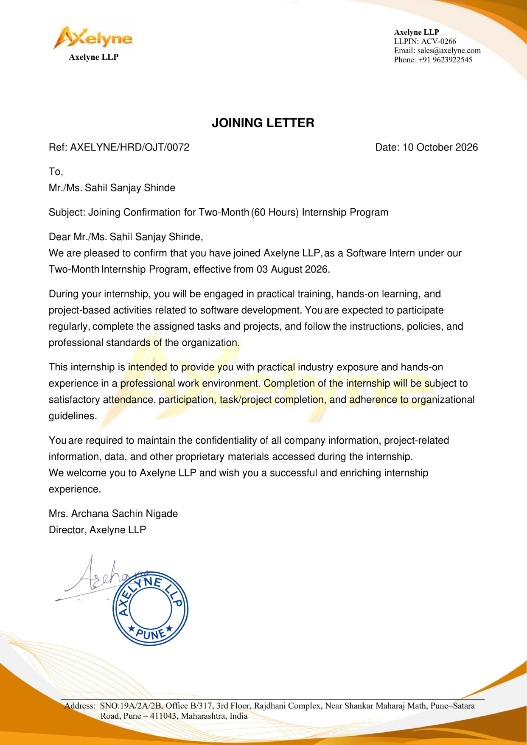
ON-THE-JOB TRAINING COMPLETION CERTIFICATE

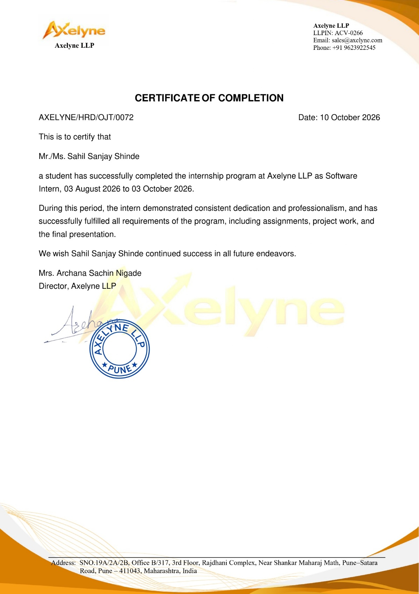


Arts, Commerce and Science College, Palus.
CERTIFICATE
This is to certify that the On-the-Job Training report submitted herewith for partial fulfilment of the B.sc. Computer Science (Entire) degree as laid down by Shivaji University, Kolhapur, is the original work completed at this college by Sahil Sanjay Shinde under our supervision and guidance, and, to the best of our knowledge, has not been submitted to any other university or examining body.

Place : Palus
Date :

Mr.Atharv Kumbhar
Examiner Co-ordinator

DECLARATION

I hereby declare that the On-the-Job Training report entitled “ClubOrbit — Clubs & Communities Platform” is a record of training completed by me at Axelyne LLP during the period from 2 Months (60 hours).
The work presented in this report is based on my learning, practical experience, and activities carried out during the training period. This report has been prepared by me as a part of the academic requirements of the B.Sc. Computer Science programme.
I further declare that the information presented in this report is true and correct to the best of my knowledge.

Place: Palus
Date:
Name: Sahil Sanjay Shinde
PRN: 2024032194
Signature:

ACKNOWLEDGEMENT
I would like to express my sincere gratitude to Axelyne LLP for providing me with the opportunity to complete my On-the-Job Training (OJT).
I am thankful to my industry supervisor, Mr./Ms. Atharv Kumbhar, for valuable guidance, support, and encouragement throughout the training period. The practical knowledge and professional experience gained during this training have helped me to enhance my technical skills and understand the working environment of the industry.
I express my heartfelt thanks to the Principal, Head of the Department, OJT Coordinator, and all faculty members of Arts, Commerce & Science College, Palus for their guidance and support in successfully completing this training.
Finally, I would like to thank everyone who directly or indirectly contributed to this successful completion of my On-the-Job Training.

Name: Sahil Sanjay Shinde
PRN: 2024032194
Class: B.Sc. Computer Science (Entire) III
Academic Year: 2026–2027

INDEX
Sr. No. | Contents | Page No.
1 | Student Information
2 | Introduction
3 | Objectives of Training
4 | Company Profile
5 | Training Details and Activities
6 | Technologies and Tools Used
7 | Task Undertaken
8 | Results & Snapshots
9 | Skills and Knowledge Acquired
10 | Learning Experience
11 | Conclusion

Student Information

Particulars | Details
Name of Student | Sahil Sanjay Shinde
Class | B.Sc. CS (Entire) Part III
PRN | 2024032194
Name of Company | Axelyne LLP
Company Address | Office No. B/317, 3rd Floor, Rajdhani Complex, Near Shankar Maharaj Math, Pune–Satara Road, Dhankawadi, Pune – 411043, Maharashtra, India
Training Domain | Web Development – Django
Training Duration | 60 Hours / From 2 Months (60 hours).
Industry Supervisor | Mr.Atharv Kumbhar
Faculty Guide | Mr.S.B.Jadhav

Introduction

Project Background and Need
ClubOrbit was developed as a practical web-development project during the On-the-Job Training (OJT) programme. The project focuses on providing a dedicated online platform where users can discover communities based on their interests, connect with like-minded people, participate in discussions and stay informed about upcoming events. Instead of using separate platforms for community interaction, event management and online discussions, ClubOrbit brings these features together in a single web application.
The project also demonstrates how a dynamic website can be developed using Python and Django. The training introduced HTML, CSS, Bootstrap and Python before the Django implementation. These technologies were then applied together while developing the project pages, templates, database-related functionality, authentication and administrative management.
ClubOrbit provides several features, including club discovery, community membership, discussion posts, threads, comments, event registration, announcements and member management. The application is organized into public pages, such as Home, Events, About and Contact, and authenticated pages, such as Clubs, Discussions and Profile. The Home page presents featured clubs and trending communities, while the Events page allows users to explore upcoming events, view event details and register for activities.
The project also supports communities related to technology, photography, gaming, music, entrepreneurship and other interests. Authentication functionality allows users to join clubs, create discussions, follow communities, attend events and manage their profiles. Additional features, such as publishing announcements, creating events and moderating discussions, help community administrators manage their clubs effectively. These features make the platform interactive, organized and useful for people who want to connect with others who share similar interests.
On-the-Job Training (OJT) is an important part of the B.Sc. Computer Science programme. It provides practical knowledge and experience in a professional software-development environment.I completed my OJT at Axelyne LLP. The training covered HTML, CSS, Bootstrap, Python, Django, project implementation, testing and documentation.During the project work, I developed "ClubOrbit — Clubs & Communities Platform," a web-based community platform designed to help users discover interest-based clubs, communicate with members, participate in discussions and explore upcoming events. The application provides a centralized platform where users can join communities, share ideas, interact with other members and participate in organized activities.ClubOrbit includes public pages such as Home, Events, About and Contact. After logging in, users can access additional features through the Clubs, Discussions and Profile pages. The platform supports club membership, discussion creation, posts, threads, comments, event registration, community following and profile activity tracking. It also includes administrative features for managing members, publishing announcements, creating events and moderating discussions.
The project helped me understand how web-development technologies can be combined to create an interactive and user-friendly application. It also provided practical experience in implementing website navigation, designing user interfaces, managing data, handling authentication, organizing community-related functionality and developing dynamic web pages using Django.

Objectives of Training
Detailed Training Objectives
The training objectives were implemented through a combination of technical learning and practical project work. The first objective was to understand web-development fundamentals and apply them to create properly structured web pages. HTML was used for page structure, CSS for visual design and Bootstrap concepts for developing responsive and user-friendly interfaces.
A second objective was to strengthen Python programming knowledge. The training covered conditionals, lists, iterations, dictionaries, functions and object-oriented programming. These concepts provided the programming foundation required to understand Django application development and implement the logic needed for dynamic web applications.
Another important objective was to understand Django as a backend web framework. The training covered project and app creation, settings, URL configuration, views, templates, models, database migrations, CRUD operations, administration and authentication. These concepts were applied during the development of ClubOrbit, a web-based clubs and communities platform designed to help users discover interest-based communities, interact with members and participate in events.
The training also aimed to develop practical skills in implementing interactive website features. The ClubOrbit project provided an opportunity to understand club discovery, membership management, discussion creation, posts, threads, comments, event registration, community following and profile activity tracking. It also helped develop an understanding of user authentication, database operations, event management and the relationship between frontend interfaces and backend functionality.
In addition to technical knowledge, the training aimed to improve professional abilities such as problem-solving, teamwork, communication, time management, testing, documentation and presentation. Completing the ClubOrbit project provided practical experience in applying these skills to an assigned software-development task and demonstrated how web-development technologies can be used to build an interactive platform that connects people with shared interests.
- Specific Objectives of Training
- The specific objectives of the training were:
- To gain practical knowledge of computer science concepts through software-development activities.
- To understand how a software-development company plans, develops and tests applications.
- To develop web-development skills using HTML, CSS, Bootstrap, Python and Django.
- To learn professional development tools such as Visual Studio Code.
- To gain experience with database operations, CRUD concepts, user authentication and authorization.
- To understand the development of dynamic web pages using Django templates, views, models and URL routing.
- To learn how to develop community-platform features, including club listings, memberships, discussion posts, threads, comments and event registration.
- To understand how web applications help users discover communities based on interests such as technology, photography, gaming, music and entrepreneurship.
- To improve communication, teamwork and problem-solving skills.
- To understand industry practices, time management and professional ethics.
- The ultimate objective was to apply the knowledge gained during the training to the development of the ClubOrbit — Clubs & Communities Platform project.

Company Profile

Name of the Company: Axelyne LLP
Address: Office No. B/317, 3rd Floor, Rajdhani Complex, Near Shankar Maharaj Math, Pune–Satara Road, Dhankawadi, Pune – 411043, Maharashtra, India
Website: axelyne.com
Axelyne LLP is a technology-driven software development and digital solutions company headquartered in Pune, Maharashtra. It provides custom software development, web and mobile applications, cloud solutions, AI-powered applications and digital marketing.
The company works with startups, SMEs, enterprises, educational institutions and government organizations. Its team includes software developers, full-stack engineers, mobile developers, UI/UX designers, cloud engineers, QA engineers, project coordinators and technical mentors.
Services include custom software development, website design and development, mobile application development, cloud solutions, AI/ML solutions, UI/UX design, digital marketing and SEO, software maintenance and technical support.
The supplied company document lists technologies such as Java, Spring Boot, Python, React.js, Flutter, Angular, Node.js, MySQL, PostgreSQL, MongoDB, AWS Cloud, Docker, Git, REST APIs, Microservices, AI/ML and DevOps.
Axelyne also conducts OJT and internship programmes with exposure to the Software Development Life Cycle, version control, agile methodology, code reviews and cloud deployment.
Training Details and Activities
5.1 Module-wise Training Overview
The complete training programme was planned for 60 hours. The training was divided into four modules to ensure a systematic progression from frontend web-development fundamentals to Python programming, followed by Django framework concepts and finally practical project implementation. Since ClubOrbit is a Django-based web application, the Django-related curriculum was directly connected to the development of the final project.
Module 1: HTML, CSS and Bootstrap
Module 1 covered the fundamentals of frontend web development using HTML, CSS and Bootstrap. The activities included page structure, text formatting, lists, tables, forms, multimedia tags, responsive design, Flexbox and Grid systems, and Bootstrap components. These concepts supported the development of consistent and user-friendly interfaces for ClubOrbit, including the Home, Clubs, Events, Discussions, Profile, About and Contact pages.
Module 2: Python Programming
Module 2 focused on Python programming fundamentals. The topics included Python revision, conditional statements, lists, iterations, dictionaries, functions and object-oriented programming. These concepts provided the programming foundation required to understand Django application development and implement the backend logic of ClubOrbit, including community management, discussion handling and event-related functionality.

Module 3: Django Framework
Module 3 covered Django installation and configuration, project and application creation, templates, models, views, URL routing, CRUD operations, database migrations, Django Admin, authentication, authorization, image and media handling, and static resource management. These concepts were relevant to developing ClubOrbit's dynamic features, including club creation and membership management, discussion posts, threads, comments, event registration, user profiles and community administration.
Module 4: Project Implementation
Module 4 focused on applying the knowledge gained during the training to the development of ClubOrbit — Clubs & Communities Platform. The activities included project planning, interface design, database organization, dynamic page development, user authentication, feature implementation, testing, debugging, documentation and project presentation. The module provided practical experience in integrating frontend and backend components into a structured web application that enables users to discover communities, participate in discussions and attend events.
The training programme consisted of 60 hours and included separate Django and React learning tracks. Since ClubOrbit was developed using Python and Django, only the Django-related curriculum is included in this report. The module-wise approach helped connect theoretical knowledge with practical software-development activities and provided hands-on experience in developing a web application designed to connect people with shared interests.

Work Module
Module 1 (01 Hours To 15 Hours)
HTML, CSS and Bootstrap
• HTML and CSS
• Text formatting and lists
• Tables and forms
• Multimedia tags
• Bootstrap introduction
• Responsive design and basic classes
• Flex and grid system
• Bootstrap components
Work Module
Module 2 (16 Hours To 30 Hours)
Python
• Python revision
• Conditionals and lists
• Iterations and dictionaries
• Functions
• Object-oriented programming (OOP)
Work Module
Module 3 (31 Hours To 45 Hours)
Django
• Virtual environment and Django installation
• Creating projects and apps
• Django configuration and settings
• Development server
• Templates and Bootstrap integration
• Models, views, URLs and CRUD
• Database migrations
• Superuser and admin panel
• Authentication and authorization
• Image and media handling
• Static CSS, JavaScript and images
Work Module
Module 4 (46 Hours To 60 Hours)
Project Implementation – ClubOrbit
• Project scope and real-world use case
• Planning pages, features and data
• Dynamic web application development
• Consistent navigation and responsive layout
• Django templates, models, views and URLs
• Registration, login and logout
• Access control
• Testing and error fixing
• Documentation and output screenshots
• Project presentation

Category | Technology / Tool | Purpose
Programming | Python | Application programming
Backend | Django | Web application development
Frontend | HTML | Page structure
Styling | CSS | Page design
UI Framework | Bootstrap | Responsive interface, where used
Database | SQLite | Data storage, if used
IDE | Visual Studio Code | Coding and project management
Browser | Chrome / Edge | Testing
Image | Pillow | Image handling, if used
Administration | Django Admin | Data management
Assets | CSS, JavaScript, Images | Static/media resources

Technologies and Tools Used

Task Undertaken
Practical Activities Performed in Modules
Module 1 practical work focused on understanding how a web page is constructed and styled. HTML elements were used to organize page content, while CSS concepts were applied to control the visual presentation. Bootstrap topics introduced reusable interface components and responsive design concepts. These skills supported the design of ClubOrbit pages, including Home, Clubs, Events, Discussions, Profile, About and Contact.
Module 2 practical work strengthened Python programming logic. Conditional statements supported decision-making, lists and dictionaries supported data handling, loops supported repeated operations, and functions enabled reusable blocks of code. Object-oriented programming concepts provided an introduction to object-based program organization. These concepts formed the programming foundation for developing the backend functionality of ClubOrbit, including community management, discussion handling and event-related operations.
Module 3 practical work connected programming concepts with web application development. A Django project and application structure was created, settings were configured, URLs were connected to views, templates were used to develop the user interface, and models represented application data. Database migrations supported changes to the database structure. Authentication, authorization, Django Admin, and static and media resource management were also covered. These concepts were relevant to implementing user accounts, club membership, discussion posts, event registration, profile management and other dynamic features in ClubOrbit.
Module 4 was the main project implementation stage. The pages and features of ClubOrbit — Clubs & Communities Platform were planned and developed using the knowledge gained during the training. The work focused on creating a consistent navigation structure, designing club listings and community pages, organizing discussion threads, implementing user authentication, developing event registration functionality and integrating community management features. The platform also included features for joining clubs, participating in discussions, following communities and managing user profiles. Testing and debugging were carried out to identify and correct issues during development. Documentation and screenshots were prepared as the final activities to present the project structure, features and implementation.

7.1 Project Title

ClubOrbit — Clubs & Communities Platform

7.2 Objective
To develop a web-based clubs and communities platform that provides an organized and user-friendly environment for discovering interest-based communities, joining clubs, participating in discussions, exploring upcoming events, managing user profiles and interacting with like-minded individuals. The platform aims to provide features such as club browsing, community membership, discussion creation, event registration, user authentication, announcement publishing and community management within a single web application.

7.3 Major Features
• Home page
• Club Listings and Details
• Event Management
• Discussion Forum
• Community Search
• Club Membership
• Login and logout
• Announcements
• User Profile
• Enquiry form
• Django Admin
• Static CSS and page-specific styling

7.4 Development Activities
• Understanding requirements
• Planning pages and navigation
• Creating Django project and catalog app
• Configuring settings, URLs and views
• Creating HTML templates and base template
• Creating models and database functionality
• Developing catalog and product details
• Implementing search/filter/sort
• Implementing authentication
• Developing enquiry functionality
• Managing CSS/static files
• Testing and correcting errors
• Preparing screenshots and documentation

7.5 Project Modules
Module | Description
Home | Introduction, featured clubs, trending communities
Clubs | Club listings, club details, membership and member information
Events | Upcoming events, event details and registration
Login / Logout | Authentication
Discussions | Discussion posts, threads and comments
Profile | User information, joined clubs, registered events and activity
Announcements | Publishing and displaying community announcements
Admin | Django Admin management

7.6 Django Architecture
Working of Django Architecture in ClubOrbit
ClubOrbit follows the Django architecture used for developing dynamic web applications. When a user requests a page, the URL configuration identifies the appropriate route and connects the request to a view. The view processes the application logic and communicates with the model whenever data is required.
The model represents the application data and supports database operations. In ClubOrbit, models can be used to manage user information, club details, memberships, discussion posts, comments, events, registrations and community announcements. This separation makes it possible to manage application data without placing database logic directly inside HTML templates. Django migrations provide a controlled method for applying model changes to the database.
Templates are responsible for generating the user-facing interface. ClubOrbit uses HTML templates, along with CSS and Bootstrap, to create a consistent and user-friendly design across pages such as Home, Clubs, Events, Discussions, Profile, About and Contact. A base template allows common layout elements, including the navigation bar and footer, to be shared across multiple pages. Static files such as CSS, JavaScript and images support the visual and interactive elements of the application, while media files can be used to store uploaded profile pictures, club images and other user-uploaded content.
Django Admin provides an administrative interface for managing application data. Authentication and authorization help control access to features available to registered users. These mechanisms support functionality such as joining clubs, creating discussions, commenting on posts, registering for events and managing community activities, subject to the permissions implemented in the application.
This architecture helps keep ClubOrbit organized into separate and understandable components. By separating URL routing, application logic, database operations and interface presentation, Django makes the development and maintenance of the ClubOrbit application easier to manage.
In summary, ClubOrbit follows Django's Model-View-Template (MVT) architecture: URLs route requests to views; views process application logic and interact with models; models represent database data; templates generate the user interface; static and media files provide visual assets and uploaded content; Django Admin supports administrative management; and authentication and authorization help protect restricted functionality.

Results & Snapshots
Results and Functional Outcomes
The completed ClubOrbit project provides a web-based clubs and communities platform designed to help users discover interest-based communities, interact with like-minded individuals and participate in discussions and events. The Home page introduces the application and displays featured clubs and trending communities. The Clubs page allows users to explore available clubs, view club details and discover members, while the Events page provides information about upcoming events, event details and registration options.
The application includes features for joining clubs, creating discussion posts and participating in conversations through threads and comments. Community-following functionality supports continued interaction among users, while club memberships provide opportunities for people to connect with others who share similar interests. The platform supports communities related to technology, photography, gaming, music, entrepreneurship and other interest areas.
The application also contains About and Contact pages to provide information about the platform, explain how it works and offer communication and support options. After login, users can access the Discussions page to participate in community conversations and the Profile page to view their clubs, registered events and activity. Authentication helps restrict selected functionality to registered users, according to the permissions implemented in the application.
The project is developed using Python and Django, with HTML, CSS and Bootstrap supporting the user interface. Django Admin provides an administrative interface for managing application data. The platform also supports community administration features, including member management, announcement publishing, event creation and discussion moderation, depending on the implemented functionality. The combination of these technologies demonstrates the practical implementation of a dynamic, database-driven web application.
The screenshots included in this report document the major working screens of ClubOrbit. Each figure represents an important page or feature of the completed project and provides visual evidence of its implementation.
Figure 1: ClubOrbit Home Page



Figure 2: Collections / Catalog Page



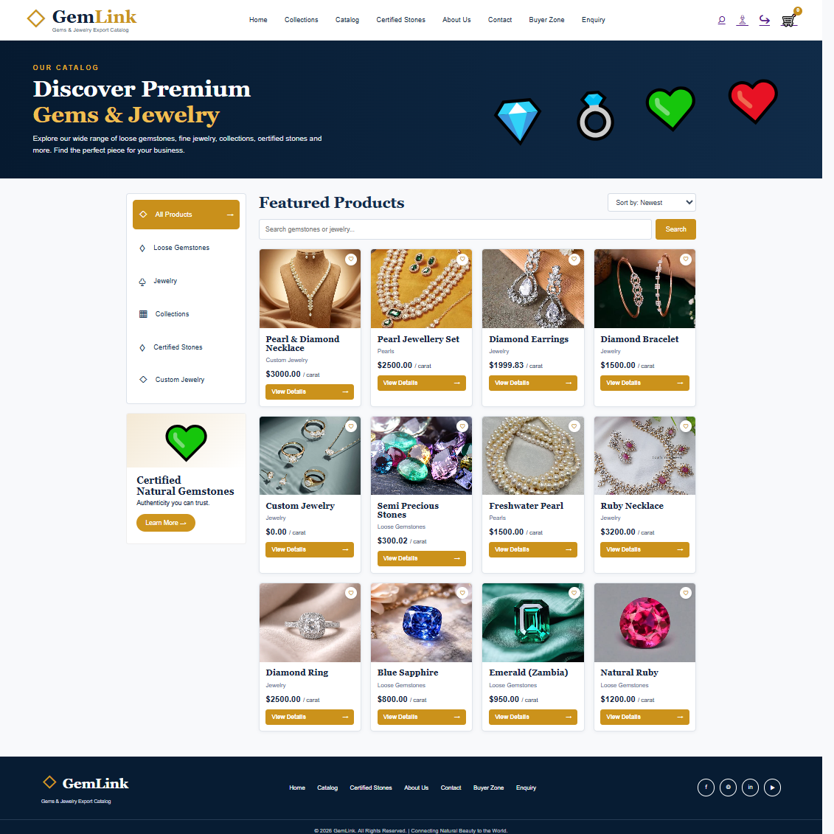

Figure 3: Product Details Pages



Figure 4: Search, Filter and Sorting
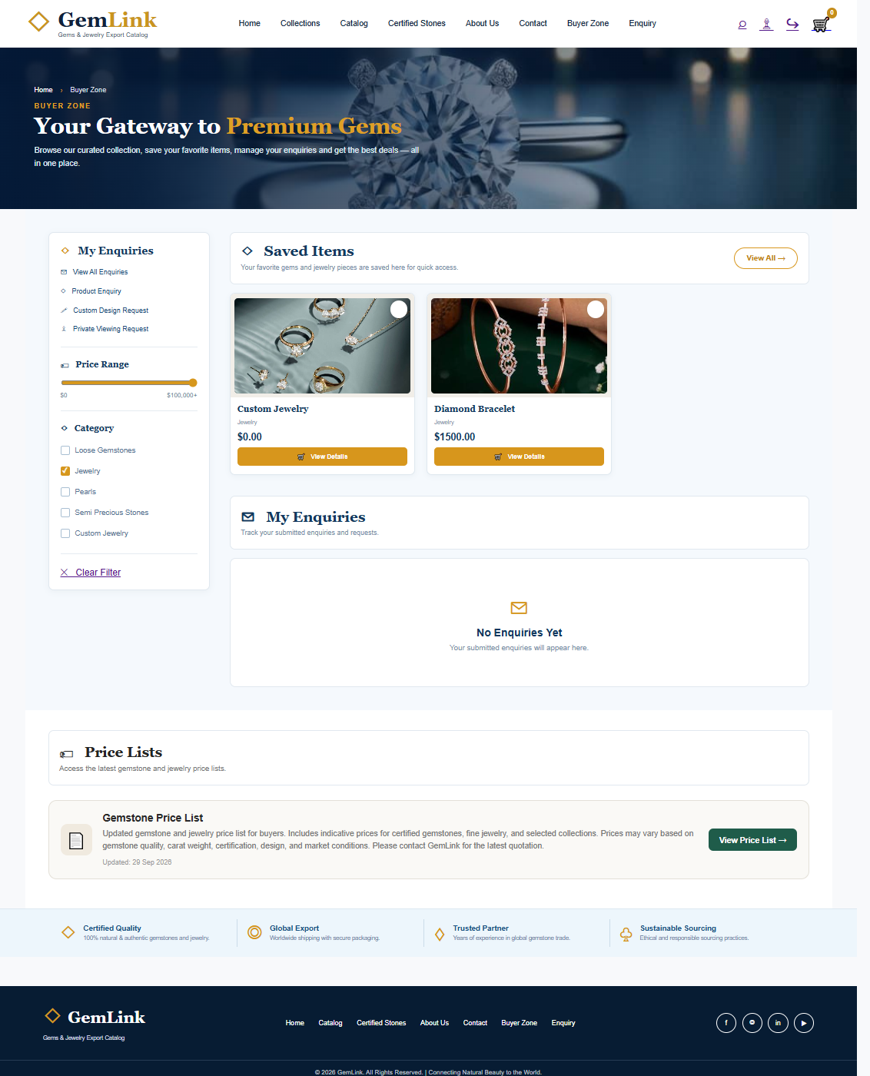

Figure 5: About Page

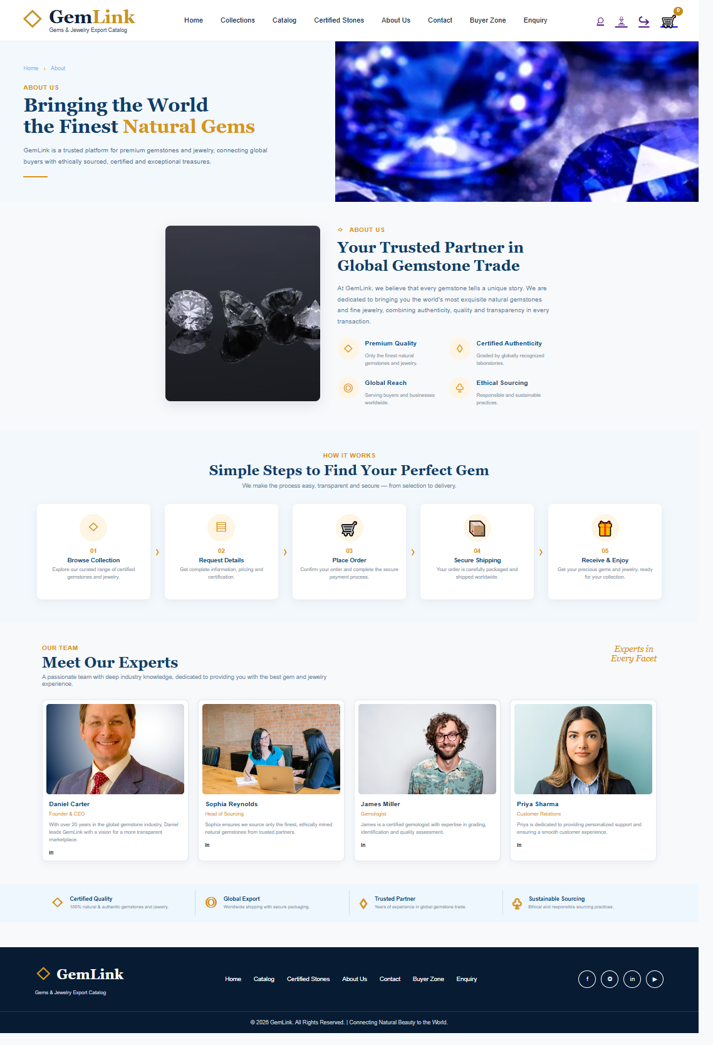

Figure 6: Contact Page
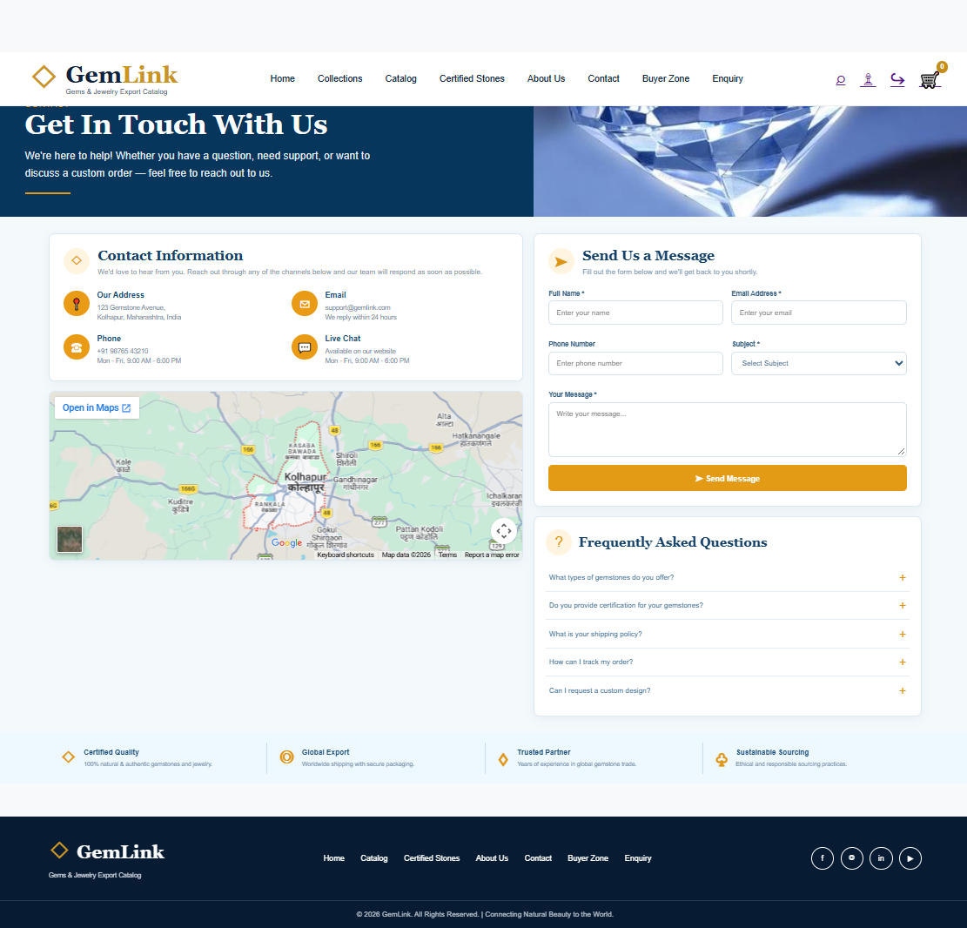
Figure 7: Certified Stones Page

Figure 8: Login Page

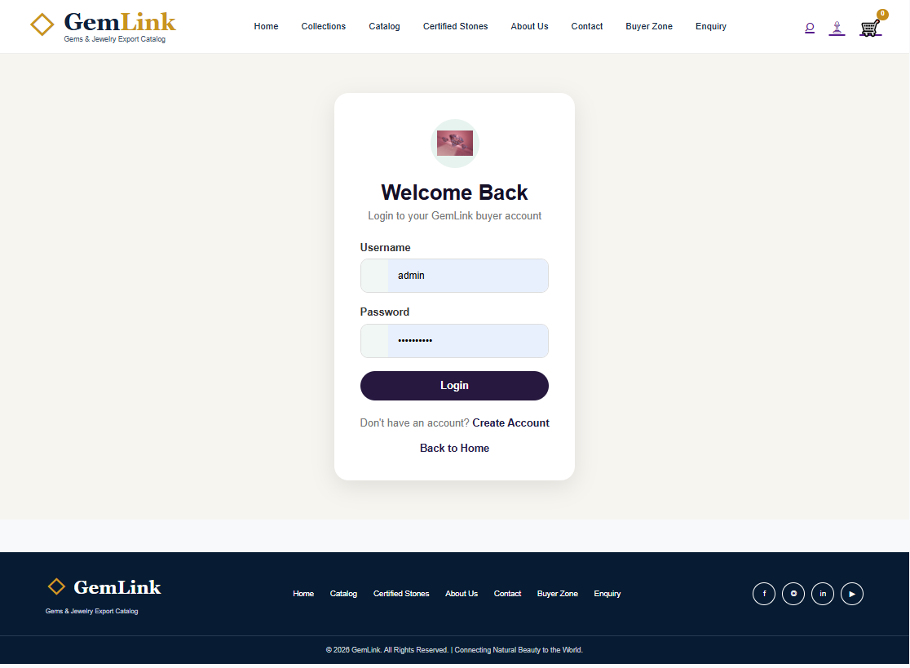

Figure 9: Certification Page

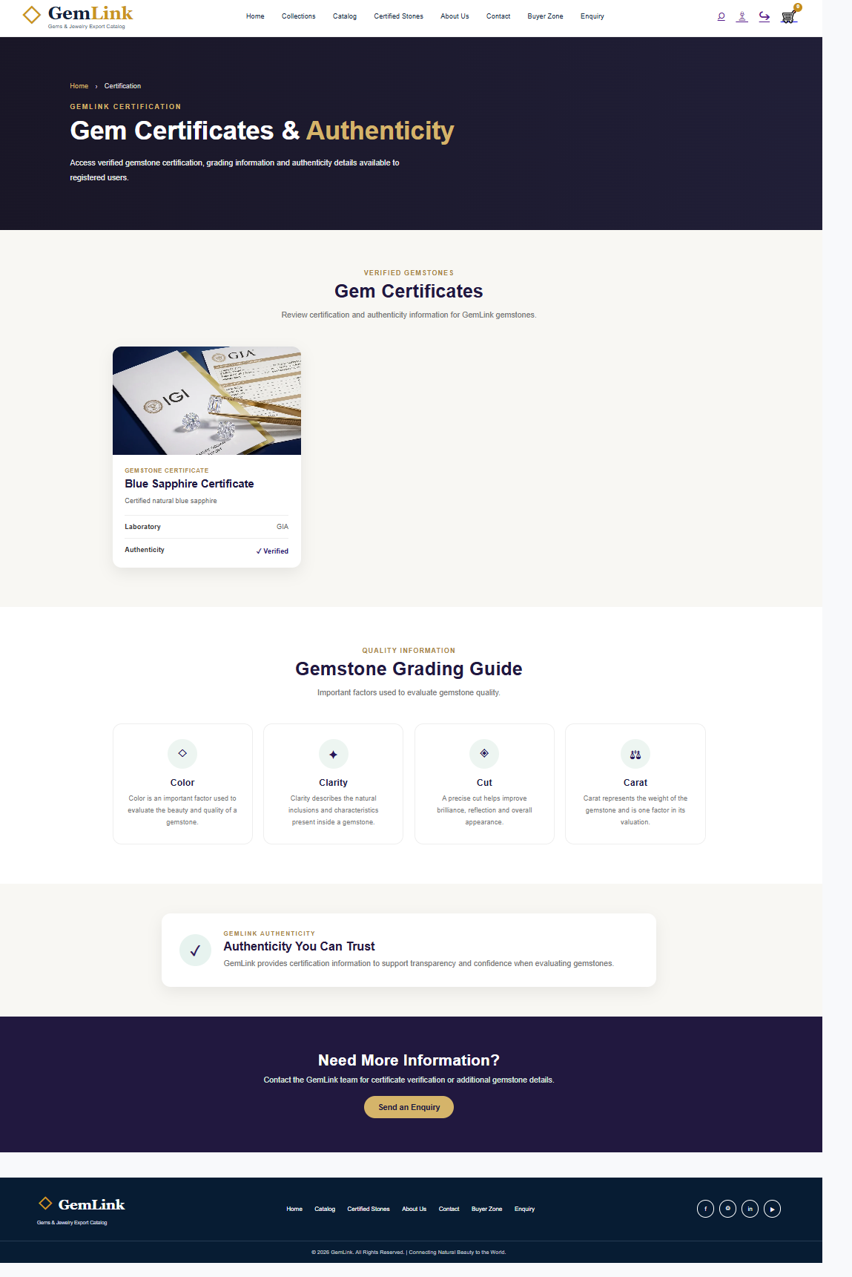

Fihure 10 :Buyer Zone Page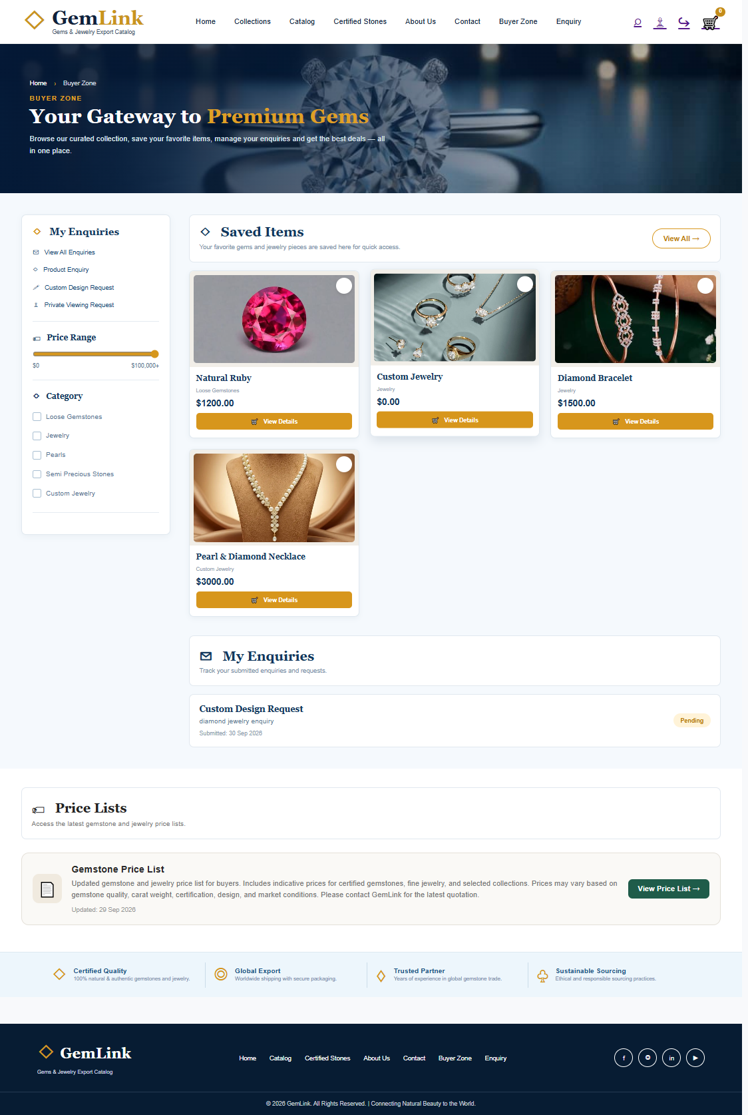

Figure 11: Enquiry Page

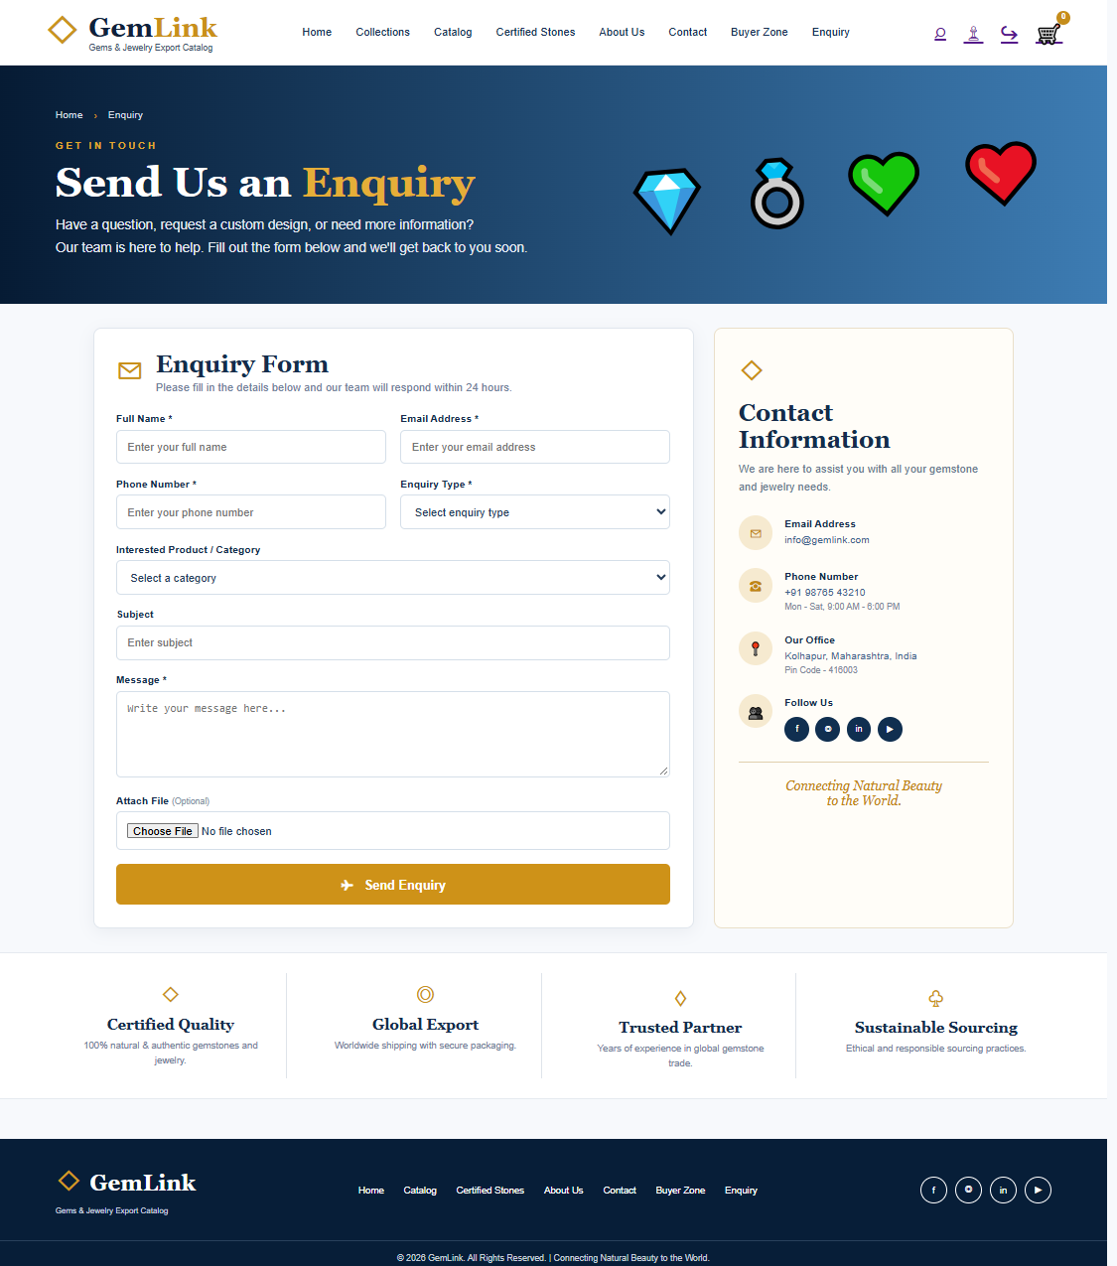

Figure 12: Django Admin Panel

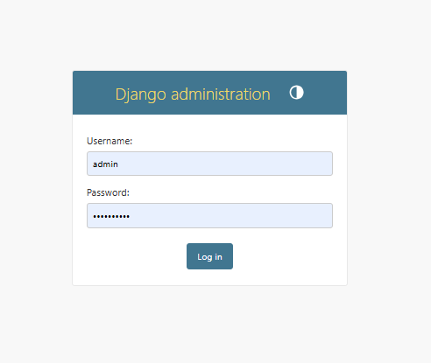
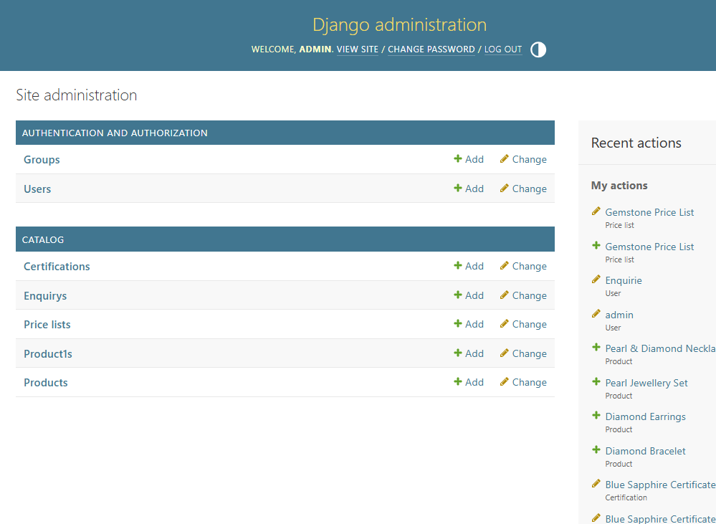

Figure 13: Logout and Dashboard

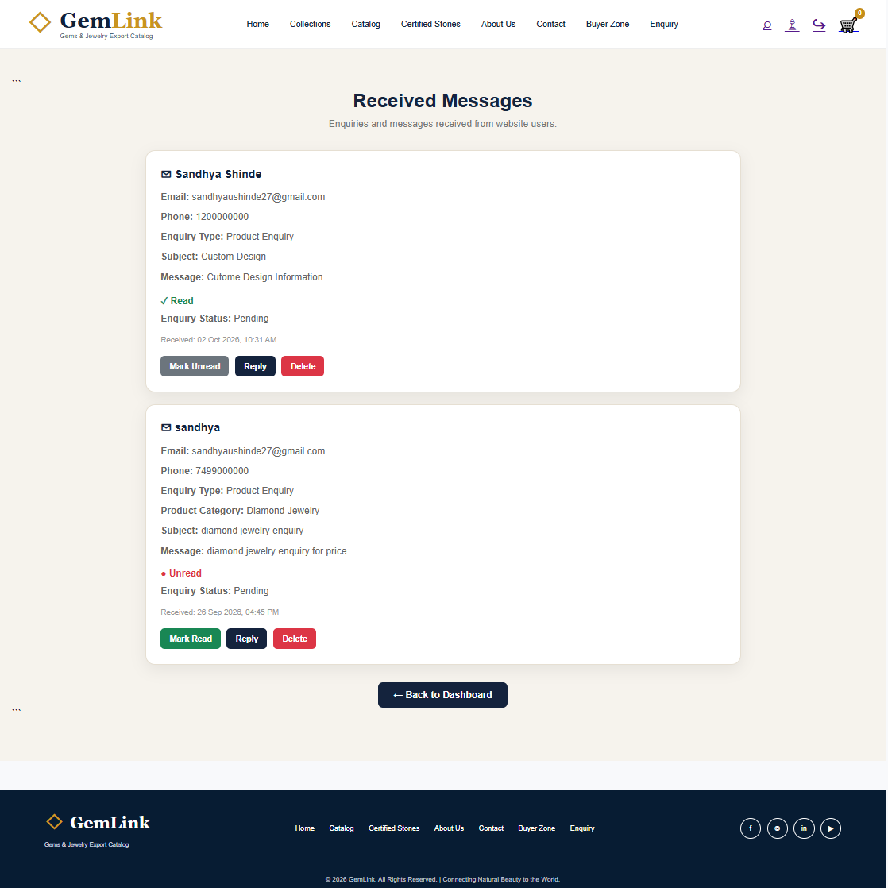

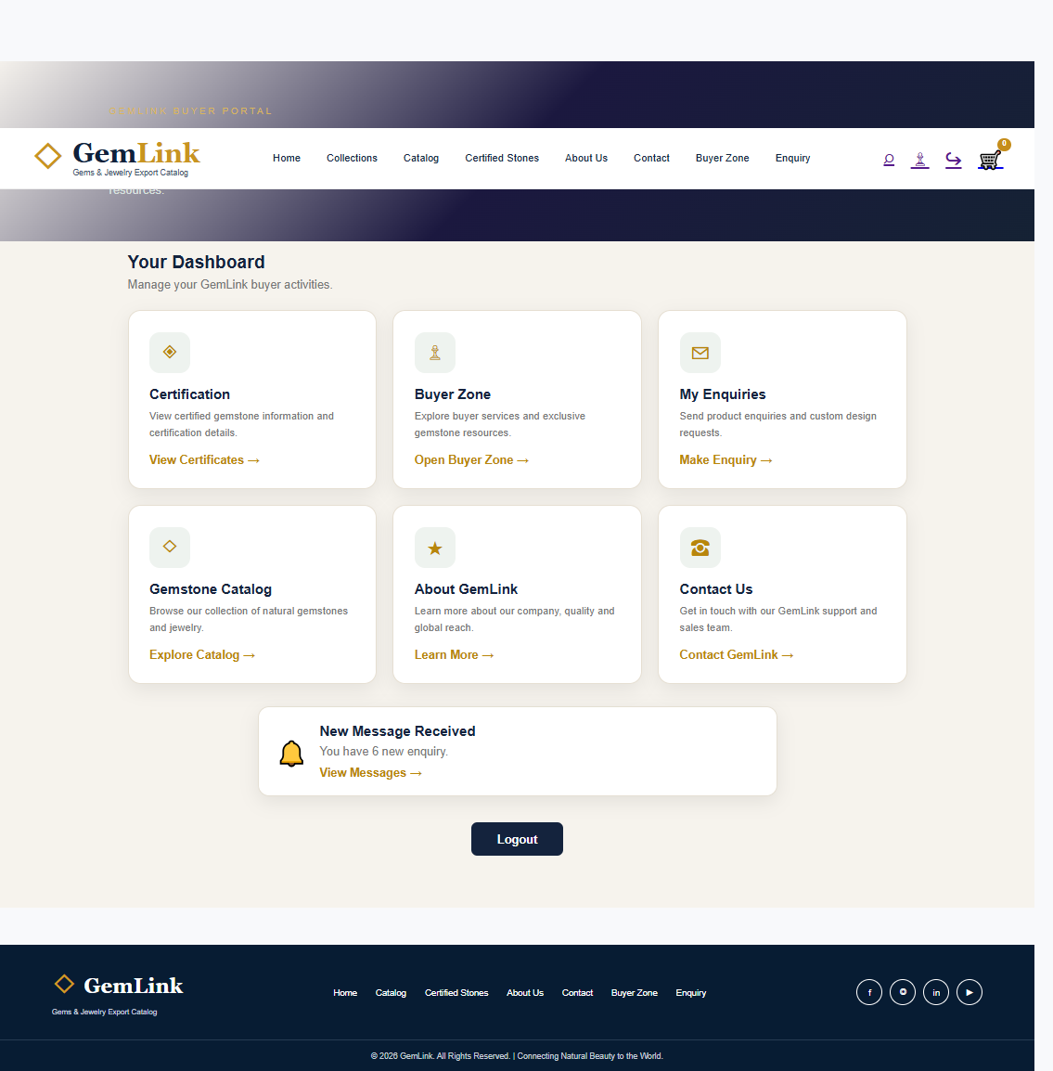

Skills and Knowledge Acquired

Technical Skills Developed
The OJT improved practical knowledge of Python and Django programming. The training provided experience with Django project and app structure, URL routing, views, models, templates, migrations and CRUD concepts. These concepts were not studied only as theory; they were applied during the development of the ClubOrbit project, a web-based clubs and communities platform designed to connect users with shared interests.
Frontend development skills also improved through the use of HTML, CSS and Bootstrap. The project required maintaining a consistent page structure and visual design across multiple screens, including Home, Clubs, Events, Discussions, Profile, About and Contact. Static CSS, JavaScript and image resources were organized as part of the application to support its appearance and functionality.
Database knowledge improved through model-based data management and Django Admin. The project provided an understanding of how application data, such as user information, club details, memberships, discussion posts, comments, events and registrations, can be organized and managed through database operations. Authentication and authorization concepts provided practical knowledge of login-based access control and the management of features available to registered users.
The development of ClubOrbit also provided an opportunity to understand the implementation of community-oriented features, including club discovery, membership management, discussion creation, posts, threads, comments, event registration and community following. Implementing features related to event management, announcements and member administration further demonstrated how web applications can organize information and facilitate interaction among users with similar interests.
Testing and debugging helped develop the ability to identify problems, correct errors and improve application functionality during development. Preparing project documentation and screenshots also strengthened the ability to explain the application structure, features and implementation process.
Along with technical skills, the project improved problem-solving, documentation, presentation, communication, teamwork and time-management abilities. These skills are important for completing software-development tasks efficiently and working effectively in a professional environment.

• Python and Django programming
• HTML, CSS and Bootstrap
• Django project/app structure
• Models, views, URLs and templates
• Database operations and CRUD concepts
• Authentication and authorization
• Django Admin
• Static and media file handling
• Testing and debugging
• Problem solving
• Documentation and presentation
• Communication, teamwork and time management

Learning Experience

The OJT programme provided valuable practical experience in web development and software development. I learned how theoretical concepts are applied to the development of a real-world web application.
During the Django training, I learned Python fundamentals, Django installation and configuration, projects and apps, templates, models, views, URLs, CRUD operations, migrations, Django Admin, authentication and authorization, image and media handling, and static asset management.
While developing ClubOrbit, I applied these concepts to a practical clubs and communities platform. I learned how to connect URLs and views, design templates, manage application data, implement user authentication and develop features related to club discovery, membership management, discussion posts, threads, comments, event registration and community interactions. The project also provided an opportunity to understand how events, community announcements and member management features can be implemented through a web interface. Testing and debugging helped me identify and correct development errors.
The training also improved my understanding of professional practices, including task completion, project file management, problem-solving, documentation preparation and project presentation. Working on ClubOrbit helped me understand the different stages involved in developing a web application, from planning and interface design to implementation and testing.

Overall, the OJT programme strengthened my technical knowledge, improved my practical programming skills and provided valuable experience in applying web-development concepts to the ClubOrbit — Clubs & Communities Platform project.

Conclusion

The ClubOrbit — Clubs & Communities Platform project provided practical experience in applying web-development concepts learned during the OJT. The project combined HTML, CSS, Bootstrap, Python and Django to develop an interactive platform for discovering communities, sharing ideas and participating in events.
The application includes features such as club discovery, membership management, discussions, comments, event registration and profile management. It also provides Home, Clubs, Events, Discussions, Profile, About and Contact pages.
The OJT improved my technical knowledge and professional skills, including problem-solving, testing, debugging, documentation and time management.
Overall, the training strengthened my Django development skills and helped connect academic knowledge with practical software development. ClubOrbit demonstrates how web technologies can encourage community participation and connect people with shared interests.

Place: Palus
Date:

Student Signature

